Detailed Report of the National Seminar Workshop on the Investment Plan for the Emission Reduction Program (ERP)
Jointly Organized by the REDD Implementation Centre (REDD IC)
Date: 30–31 Ashwin 2082 (16–17 October 2025) | Bhairahawa, Lumbini

1. Background
Nepal entered the global carbon finance landscape by signing the Emission Reductions Payment Agreement (ERPA) with the World Bank’s Forest Carbon Partnership Facility (FCPF) Carbon Fund on 24 February 2021. This agreement commits Nepal to reduce emissions from deforestation and forest degradation across 13 districts of the Terai Arc Landscape (TAL), covering over 5 million residents and some of Nepal’s most productive forest ecosystems.
The first ERP monitoring period (2018–2021) was successfully validated and verified by the independent Validation and Verification Body (VVB). Based on verified emission reductions, Nepal secured a USD 9.4 million payment—the first global performance-based climate finance payment of this scale in the forestry sector for Nepal.
Following the finalization of Nepal’s Second National REDD+ Strategy (2025–2034), the country is positioned to strengthen its results-based climate action framework. To ensure transparent, equitable, and results-oriented utilization of benefits generated under the Emission Reduction Program (ERP), Nepal is mandated to design and operationalize a comprehensive Investment Plan (IP)—a strategic planning instrument that aligns directly with the national Carbon Benefit Sharing Plan (BSP).
The Investment Plan (IP) will function as the principal framework guiding Divisional Forest Offices (DFOs), Protected Areas (PAs), Community Forest User Groups (CFUGs), and other local stakeholders in planning, prioritizing, and effectively allocating performance-based payments. The IP will reinforce the Strategy’s core pillars—forest governance, safeguards, carbon accounting, community empowerment, and climate-resilient livelihoods—ensuring that performance payments directly contribute to reduced deforestation, improved forest management, and strengthened Indigenous Peoples’ and Local Communities’ (IPLCs) benefits across the ER Program area.
In this context, a 1.5-day consultation workshop was held in Bhairahawa to:
- Validate the draft Investment Plan
- Ensure alignment between BSP and district-level annual programs
- Strengthen coordination among MoFE, REDD IC, Provinces, and DFOs
- Prepare for roll-out of ER benefits to communities by FY 2082/83
A total of 67 participants (Detailed attendance in Annex) —including senior officials, provincial and district forest authorities, and national park representatives—participated.

2. Objectives of the Workshop
The workshop aimed to:
- Provide an orientation on the draft Investment Plan (IP) Template ( in Annex) and expected institutional arrangements.
- Review forest area and performance data from 13 TAL districts, 16 Divisional Forest Offices, and 5 National Parks.
- Clarify roles and responsibilities for operationalizing the Carbon Benefit Sharing Plan (BSP).
- Agree on priority investment areas for emission reduction and community benefit enhancement.
- Strengthen institutional coordination through REDD Desks, REDD Focal Persons, and REDD Cells at district and provincial levels.
- Gather technical and procedural feedback for finalizing the Investment Plan.

3. Participation Profile

3.1 Gender and Ethnicity-wise Participation
Category | Male | Female | Total
Indigenous | 9 | 2 | 11
Non-Indigenous | 51 | 5 | 56
Total | 60 | 7 | 67
(Note: Low female participation reflects structural gender imbalances in forestry governance; participants recommended that future REDD+ programs ensure minimum 33% women's participation.)

4. Forest Area and Program Scope

4.1 National Parks and Protected Areas – Forest Area Overview
A total of 169,951.85 ha across 5 Protected Areas (PAs) are engaged under the ERP.
S.N. | Protected Area | Province | Core Forest | Buffer Zone CF | Religious Forest | Community Forest | Total
1 | Parsa National Park, Adhabhar | Madhesh | 9,929.90 | 9,763.32 | 286.50 | – | 20,041.34
2 | Chitwan National Park, Kasara | Bagmati | 34,774.00 | 17,406.23 | 19.68 | – | 52,213.91
3 | Banke National Park, Obhari | Lumbini | 21,196.00 | 9,993.00 | – | 13.17 | 31,202.17
4 | Bardiya National Park, Thakurdwara | Lumbini | 22,000.00 | 20,141.00 | – | 17.43 | 42,158.43
5 | Shuklaphanta National Park, Mahendranagar | Sudurpaschim | 20,229.40 | 4,120.60 | – | – | 24,350.00

4.2 Divisional Forest Offices – Annual Investment Plan & Forest Area
A combined 834,301.76 ha of forests across 16 DFOs are under the ERP.
S.N. | DFO | Province | CF | PF | Leasehold | Religious | Private Forest | Plantation | Total
1 | Rautahat | Madhesh | 8257.14 | 11927.97 | – | – | – | 1052.92 | 29,469.19
2 | Bara | Madhesh | 10575.08 | 10368.81 | – | – | – | – | 31,191.00
3 | Parsa | Madhesh | 7151.00 | 11850.56 | – | – | – | – | 19,001.56
4 | Chitwan | Bagmati | 23309.67 | – | 1454.64 | 29.85 | 10302.00 | – | 57,650.00
5 | Nawalpur | Gandaki | 39850.74 | 672.86 | 1956.00 | – | – | – | 68,476.77
6 | Parasi | Lumbini | 10278.30 | 1204.10 | – | 9.00 | – | – | 21,808.00
7 | Rupandehi | Lumbini | 16562.46 | 2085.24 | – | 27.47 | – | – | 25,105.00
8 | Lumbini/Buddhabhumi | Lumbini | 12844.94 | 8447.84 | – | 200.95 | – | – | 21,493.73
9 | Ghorahi | Lumbini | 60586.70 | – | – | 112.52 | – | – | 84,273.22
10 | Deukhuri | Lumbini | 54460.00 | – | – | 38.50 | 57337.66 | – | 111,836.16
11 | Banke | Lumbini | 26118.58 | – | – | 97.71 | – | – | 57,458.59
12 | Bardiya | Lumbini | 20629.86 | – | – | – | – | – | 20,629.86
13 | Kailali (Lamki) | Sudurpaschim | 52250.00 | – | – | – | – | – | 103,182.00
14 | Dhangadhi | Sudurpaschim | 48771.01 | 7365.05 | 58.00 | 129.48 | – | – | 96,172.06
15 | Kanchanpur | Sudurpaschim | 20410.50 | – | – | – | – | – | 47,014.45

5. Keynote Address by Dr. Rajendra Prasad KC, Secretary, MoFE
Dr. Rajendra emphasized Nepal’s strong global positioning in climate finance and stressed that the ERP represents Nepal’s flagship national program for results-based climate action. He highlighted the following:

5.1 Governance and Institutional Strengthening
- Provinces must operationalize REDD Desks with clear roles and staff.
- District-level REDD Cells should be functional and linked to REDD IC.
- Focal Persons are critical for data flow, monitoring, and reporting.

5.2 Equity and Recipients’ Rights
- Carbon benefits must prioritize Indigenous Peoples, Dalits, women, forest-dependent poor households, and remote CFUGs.
- The BSP must embed equity, inclusion, and customary rights.

5.3 Data, MRV, and Verification Quality
- Districts must ensure accurate data, GIS boundaries, and performance tracking.
- Weak documentation continues to be a bottleneck in global REDD+ efforts—Nepal must avoid such issues.

5.4 Strategic Vision
- ERP should be leveraged to transition Nepal into broader nature-based climate finance, including TFF, LEAF Coalition, and voluntary carbon markets.
- Provinces and districts must be carbon finance–ready with robust systems.

5.5 Human–Wildlife Conflict (HWC)
- HWC has become a major livelihood and safety concern; 35% of TAL funds must prioritize mitigation and relief.

6. Presentations and Technical Sessions

6.1 Presentation on the Draft Investment Plan
The REDD IC team presented the draft Investment Plan covering:
- Objectives, principles, and planning logic
- Eligible expenditure areas
- Priority activities such as SFM, bamboo plantations, water recharge ponds, fire management, biodiversity restoration
- District-level allocation formulas based on forest area and performance
- Safeguards compliance and monitoring mechanisms
Participants provided district-specific feedback on feasibility, geographic priorities, and data accuracy.
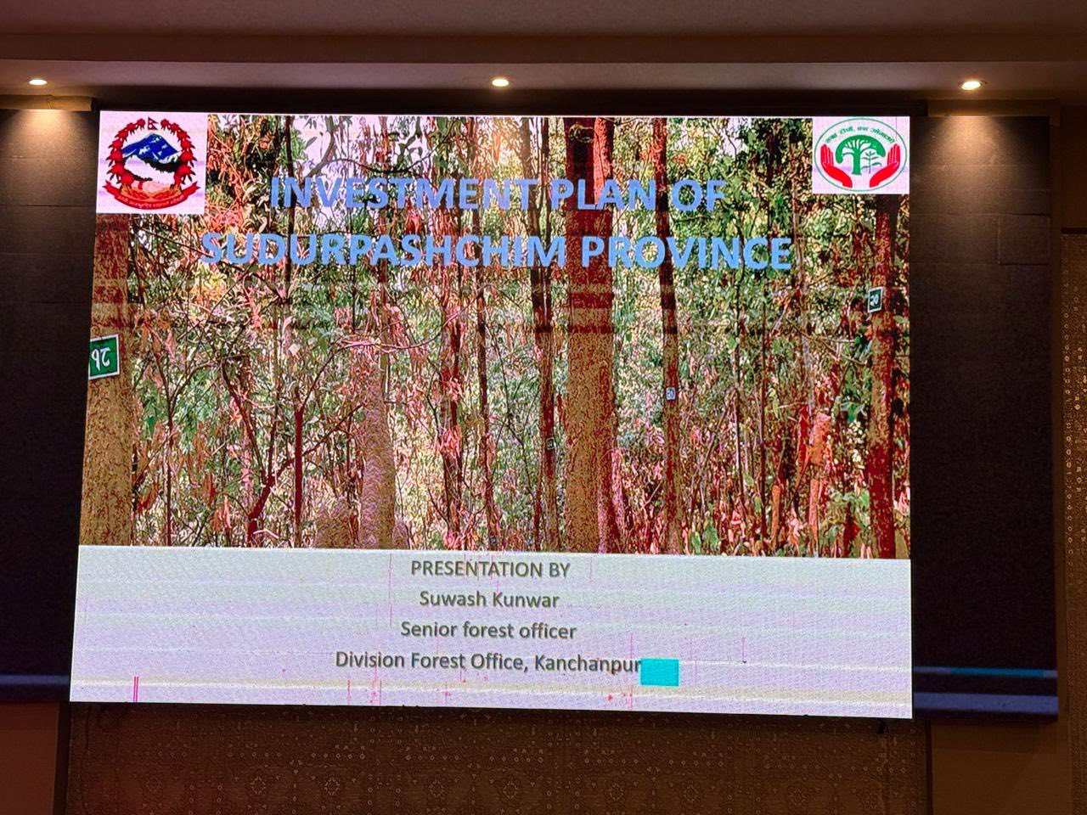
Figure 1: Investment Plan Powerpoint presentation by Sudurpaschim Province participant
7. Key Discussion Points from Participants
(Integrated from Meeting minutes ( in Annex) and program rapporteur report)

7.1 Inclusion and Equity Concerns
- CFUGs in remote and historically marginalized clusters must receive dedicated support.
- Provinces recommended performance plus equity weighting in future carbon payments.

7.2 Clarification on PAN, taxation, and fund flow
- Multiple participants asked how PAN requirements, taxation, and community-level fund flow will be handled.
- REDD IC agreed to issue simplified financial guidelines note/memo.

7.3 Overlapping Roles of Agencies
- Provinces noted lack of clarity between Forest Directorate and DFO roles post-federalization.
- Participants requested formal harmonization guidelines.

7.4 Need for Field-Level Capacity Building
- DFOs require training on MRV, safeguards, and documentation.
- DGM Nepal and REDD IC will jointly develop a syllabus.

7.5 Local Ecological Priorities
- Invasive species (Mikania, Lantana, Chromolaena) need urgent control measures.
- Participants highlighted water scarcity and groundwater depletion.
- Wildlife corridors and HWC hotspots should be reflected in district IPs.

8. Key Outcomes

8.1 Improved Shared Understanding
Participants reached a common understanding of:
- The BSP structure, performance-based criteria, and verification requirements
- The Investment Plan framework and its alignment with ERPA commitments
- Fund flow mechanisms and institutional coordination pathways

8.2 Strengthened Institutional Coordination
- REDD IC committed to increasing engagement with provincial REDD desks and DFOs.
- DGM Nepal to support capacity-building, technical training, and documentation readiness for districts.

8.3 District-Level Readiness Enhanced
- DFOs presented preliminary Investment Plans, demonstrating varying levels of preparedness.
- Agreement to refine district plans based on safeguard requirements and community priorities.

8.4 Clearer Stakeholder Roles
- Roles of MoFE, REDD IC, Provincial Ministries, DFOs, CFUGs, and DGM Nepal were clarified for the rollout of BSP and Investment Plan execution.

9. Recommendations

9.1 Strengthen Data and Reporting
- Require evidence-based reporting from DFOs and CFUGs.
- Establish a standardized data inventory capturing inclusion, gender, and Indigenous Peoples’ participation.

9.2 Enhance Inclusion and Gender Equity
- Prioritize women, Indigenous Peoples, Dalits, and marginalized groups in all decision-making and benefit-sharing processes.
- Increase targeted outreach and representation in future consultations.

9.3 Build District-Level Capacity
- Deploy dedicated technical focal persons in each TAL district.
- Provide training on Investment Plan preparation, safeguards compliance, GIS mapping, and reporting.

9.4 Address Administrative Barriers
- Simplify guidance regarding PAN number for CFUGs to ensure they are not excluded from disbursements.
- Clarify tax implications and provide support through DFOs.

9.5 Improve Communication and Coordination
- Ensure timely communication to DFOs regarding REDD+ events and consultations.
- Strengthen vertical coordination between MoFE, REDD IC, provincial ministries, and local forest offices.

9.6 Clarify Fund Flow and Governance Mechanisms
- Provide a detailed, user-friendly breakdown of the fund flow structure, transaction costs, and performance-based criteria.
- Ensure the LMBIS-based system is fully understood and accessible to district-level counterparts to manage the disbursement of performance-based payments to Community Forest User Groups (CFUGs), Protected Areas, and government-managed forest programs. This also Supports digitization and transparency in the benefit-sharing mechanism and can link with GIS-based forest inventory and monitoring systems for evidence-based fund allocation.

9.7 Support for Passive CFUGs
- Develop a targeted strategy to activate passive CFUGs through:
  - Customary and tenure rights strengthening
  - Enterprise development (36 enterprise categories noted)
  - Access to concessional loans (7% rate supported through Forest for Prosperity project, etc)
  - Capacity building activities through DGM Nepal project.
9.8 Annual Investment Planning for Emission Reductions
- District-level Annual Investment Plans must align with ERP priorities and performance-based allocation criteria.

10. Way Forward
- Consolidate all recommendations from the seminar into a technical memo for MoFE and REDD IC.
- REDD IC and DGM Nepal will jointly organize follow-up technical consultations to refine the district Investment Plans.
- Develop a uniform Investment Plan template based on lessons shared during the seminar.
- Enhance documentation, verification, and social safeguard implementation at all levels.
- Strengthen the role of provincial REDD desks, improving multilevel governance.

11. Conclusion
The two-day seminar provided a substantive platform for improving the shared understanding, coordination, and readiness of key stakeholders involved in Nepal’s ERP. The active involvement of MoFE, REDD IC, DFOs, and DGM Nepal, and the World Bank reflects strong institutional commitment to transparent, equitable, and inclusive benefit-sharing.
The recommendations and outcomes from this workshop will play an essential role in shaping the effective implementation of the Benefit Sharing Plan and the Investment Plan, ensuring carbon revenues reach forest-dependent communities in a fair, efficient, and safeguard-compliant manner.

    - The report is jointly prepared by DGM Nepal and REDD Implementation Centre.

ANNEX
  - Attendance
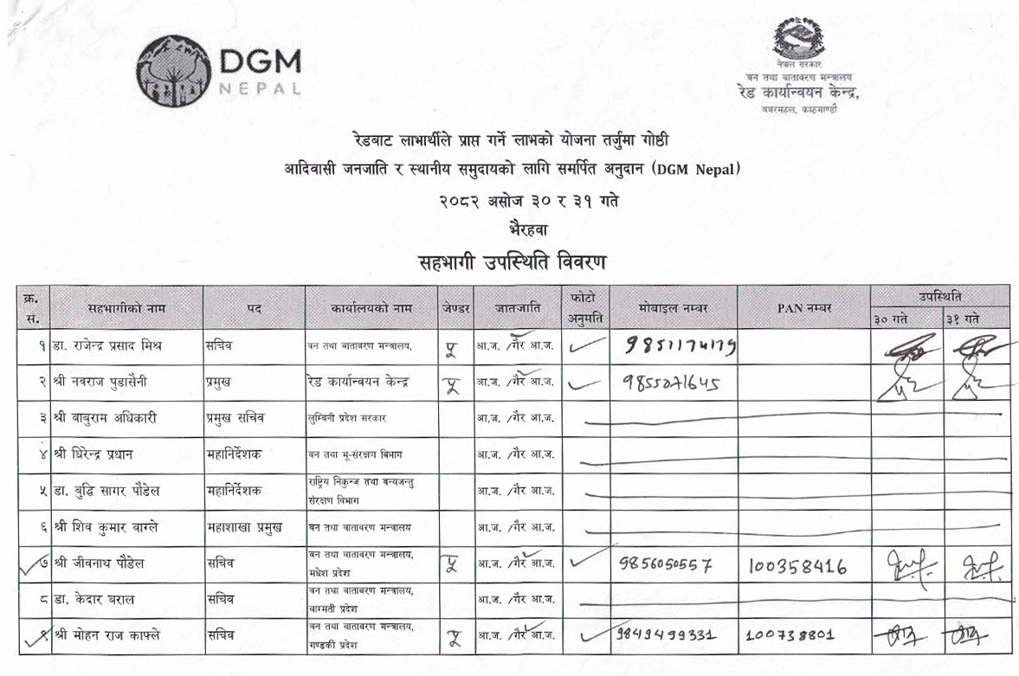
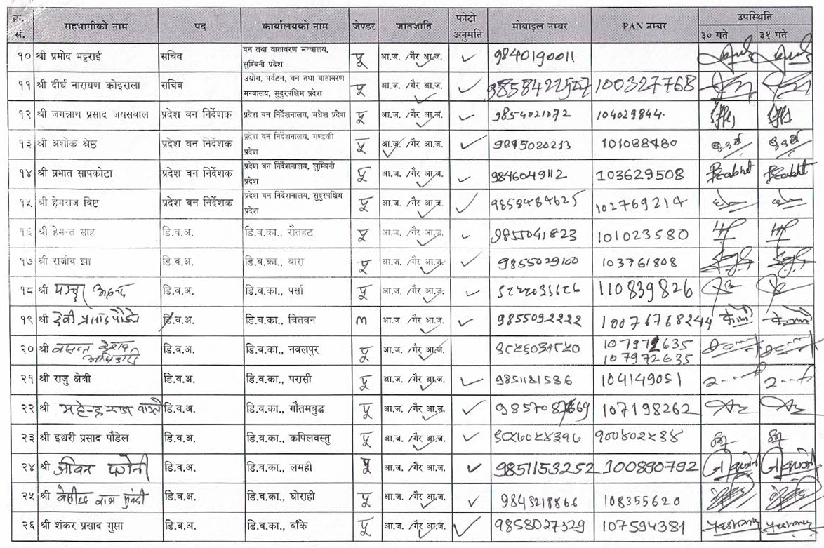
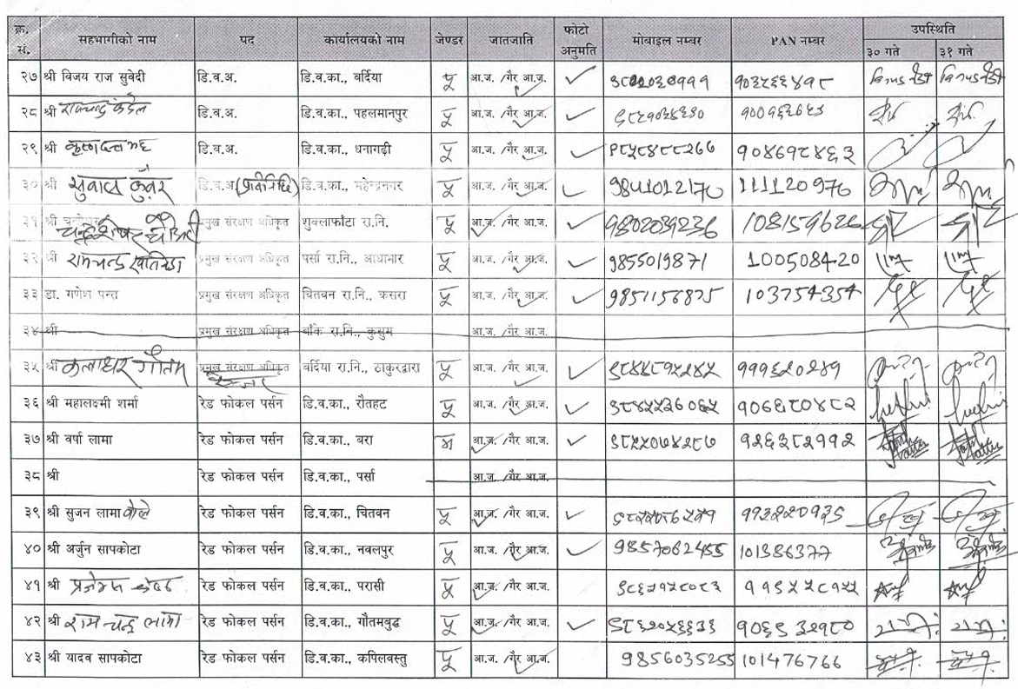
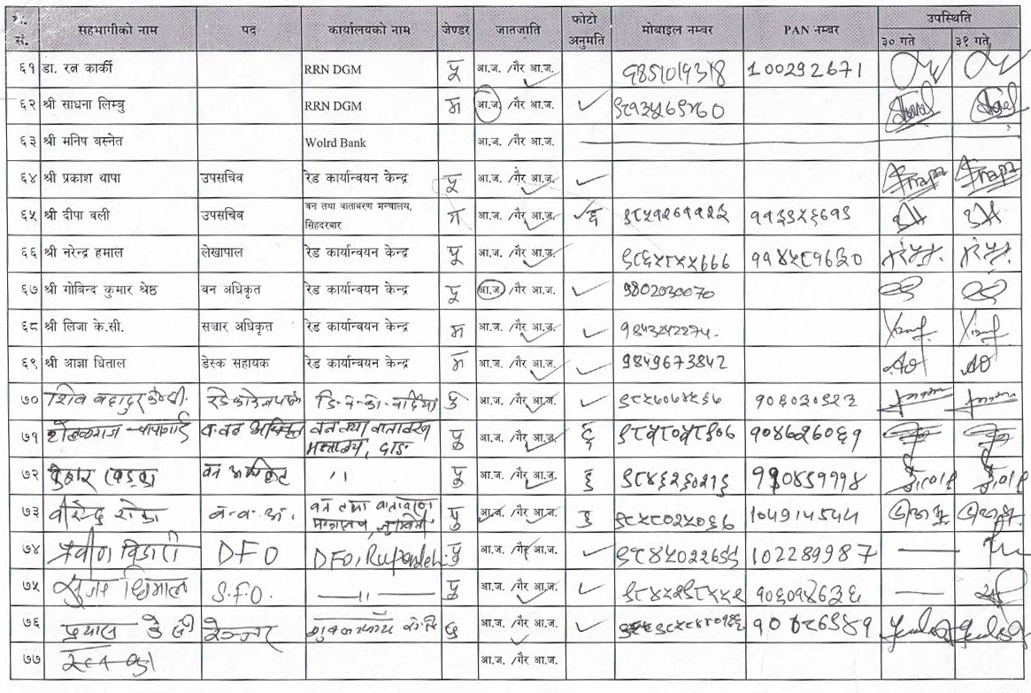
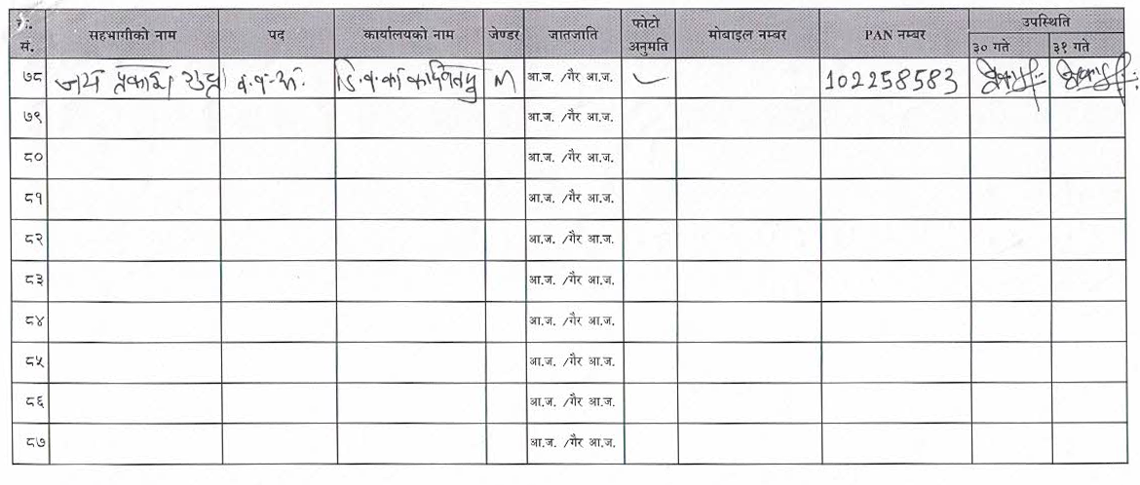

2. Photos
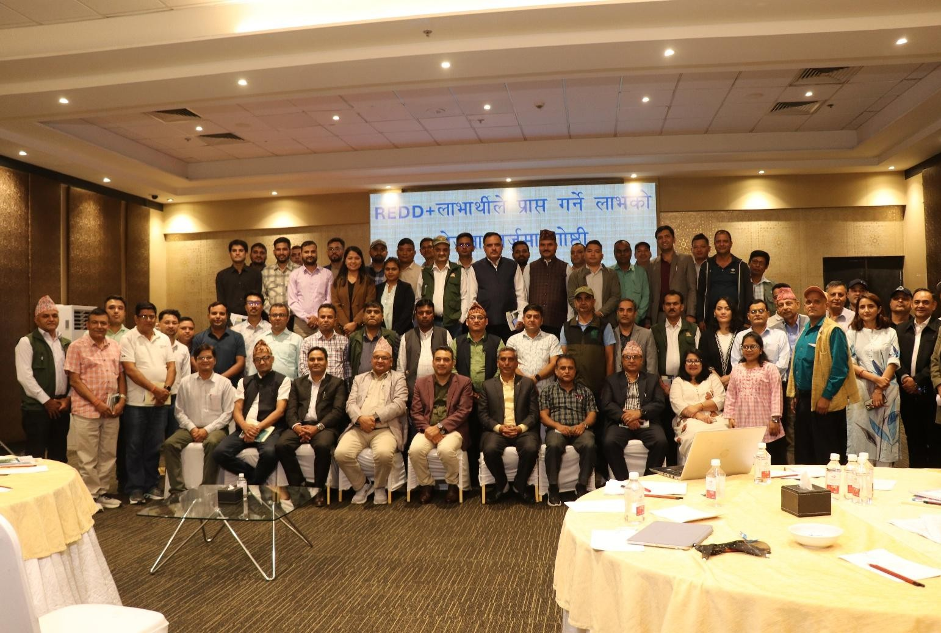
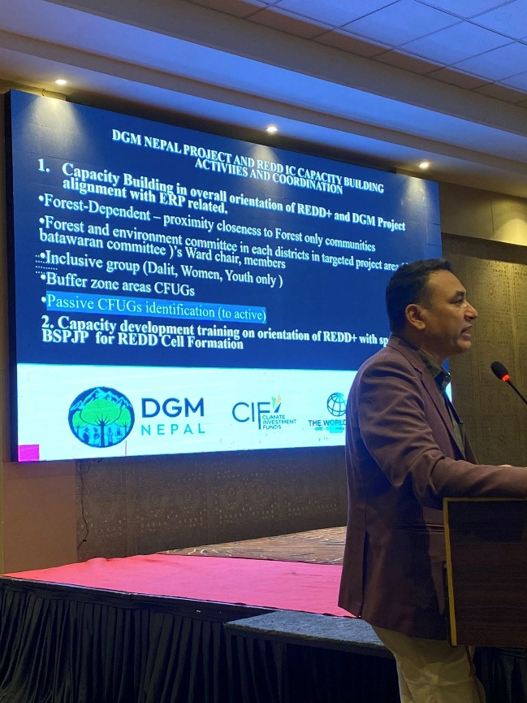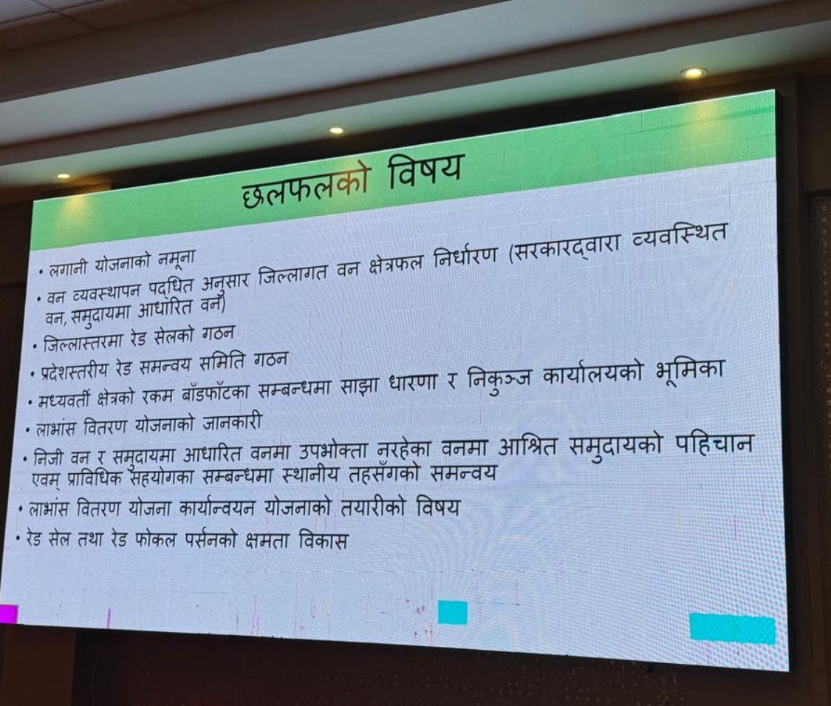

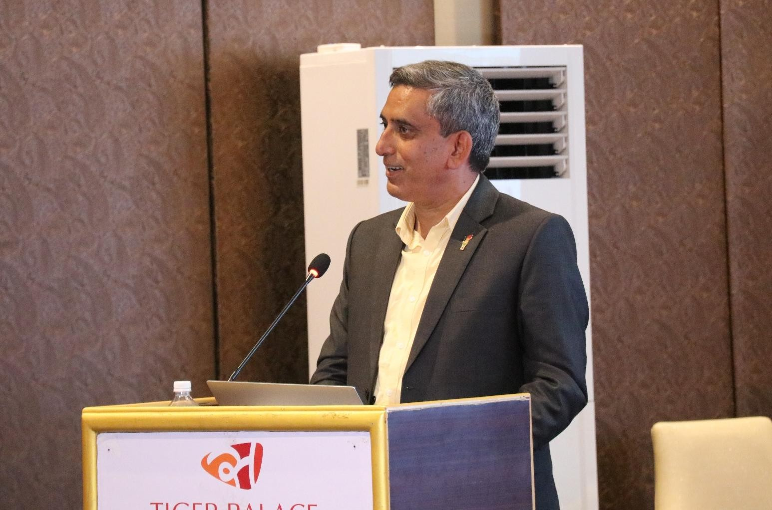
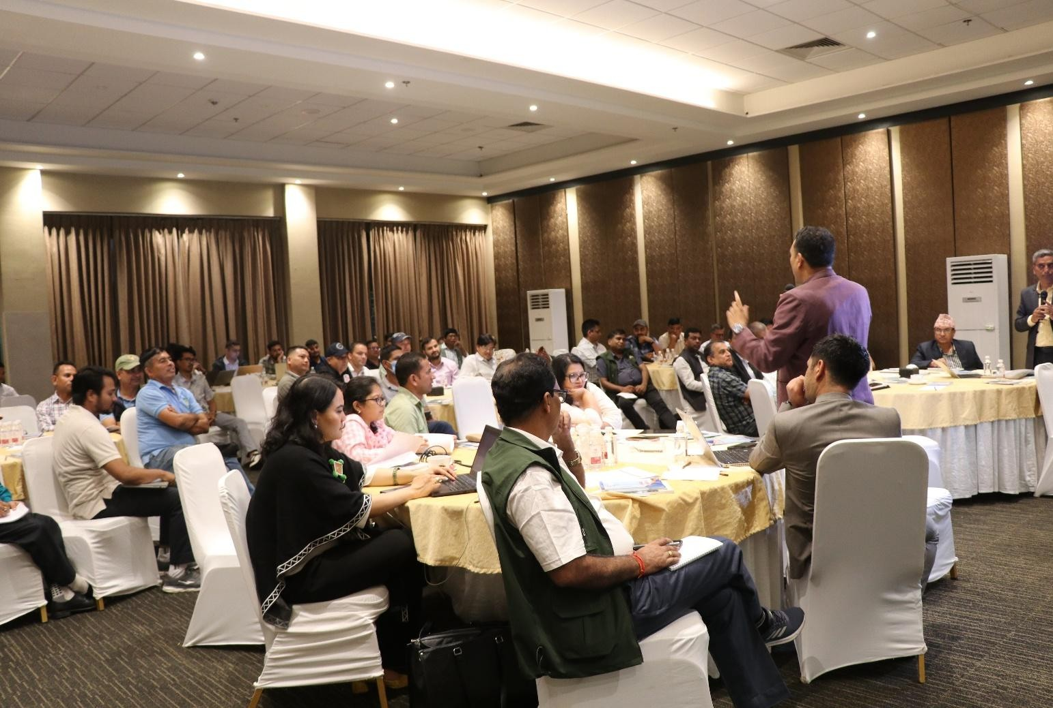
3.Meeting Minutes ( Of REDD IC)

Second National REDD+ Strategy (2025–2034) – Ministry of Forests and Environment (MoFE) Nepal_national_redd_plus_strategy_(2025_2034)(1).pdf
Benefit Sharing Plan of Emission Reduction Program, 2022

